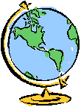
Birthplace

  - From how many countries do Australians come?

  - What percentage of the Australian population identify as being of Indigenous origins?

  - Which state/territory has the largest number of Indigenous Australians?

  - What percentage of the Australian population was born overseas?

  - From which country does the largest overseas born group come?

  - What percentage of the Australian population was born in countries where the primary language is not English?

  - What percentage of the Australian population have at least one parent born overseas?

  - How many refugees and displaced people have arrived in Australia over the last 50 years?

